
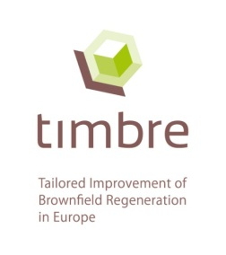
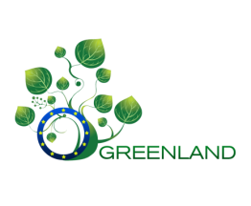
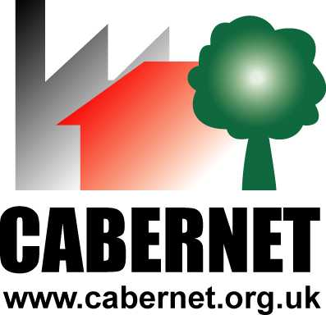
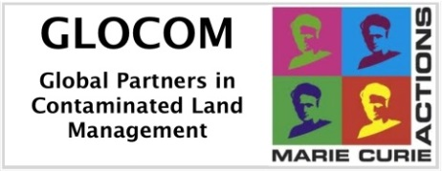
www.cabernet.org.uk www.dais.unive.it/~glocom www.greenland-project.eu www.timbre-project.eu www.zerobrownfields.eu

CABERNET 2014:
Tailored & Sustainable Redevelopment
towards Zero Brownfields

4th International Conference on Managing Urban Land

Final Conference of the EU FP7 Project "HOMBRE"
in cooperation with the EU FP7 Projects "GLOCOM",
“Greenland” and “TIMBRE”

14th – 16th October 2014
Frankfurt am Main, Germany

Call for posters
The text of maximum one page, including figures and references, should explicitly state the objectives, new results and the conclusions or significance of the work. When submitting an abstract, please provide the following information:

- Name and address (postal and e-mail) of corresponding author
- Title of your paper
- Abstract in electronic form (please use the template enclosed)
- Indicate which of the conference “key topics” your paper belongs to (please use the table enclosed)

Please send your poster abstract to Ms. Katja Wendler: wendler@dechema.de
Deadline for submission of your poster abstract is 30th September 2014. Full paper submission deadline to be included in the conference proceedings is 5th September 2014.

Key Dates:
5th September 2014 – Submission of the full text of the paper
(to be included in the conference proceedings)
18th September 2014 – 3rd Announcement
30th September 2014 – Deadline for registration and for the submission of poster abstracts
T E M P L A T E [all in Arial, line-spacing 1.5]

Title Line [in Arial 14 bold]
Author1, company/organisation1, Country1; author2, company2, Country2; author3, company3, Country3 …
Email@corresponding.author
[Arial 12 italic, + underline only presenting author as here for example author 2)
[blank line]
Body Text – include objectives, new results and the conclusions or significance of the proposed contribution [Arial 12]

Subheading [Arial 12 bold]
BodyText [Arial 12]
[blank line]
References [Arial 10]

Please indicate the conference “key topic” that your paper belongs to:
- Integrated urban land management and policies
A.1 Solutions to bring state-of-the-art knowledge and information into application
A.2 Development of decision support tools and their integration into existing systems
A.3 International and European policies, programmes and regulation
A.4 Research perspectives in Horizon 2020
- Economic, social and environmental instruments for land use management
B.1 Integrated planning and assessment of revitalization options for brownfields
B.2 Prioritisation of action needs
B.3 Early warning measurements
B.4 Drivers for brownfield regeneration
B.5 Stakeholder involvement
B.6 Biomass production on marginal soils: carbon sequestration and energy yield
B.7 Valorisation options for biomass produced on marginal or contaminated land
- Innovative technologies and management tools for land revitalization
C.1 Decision support tools on technologies for land revitalization
C.2 Emerging strategies and technologies for effective site characterisation and remediation
C.3 Strategies for the environmentally friendly destruction of buildings and re-use of infrastructures and materials
C.4 Strategies for the environmentally friendly management of industrial landscapes and buildings
C.5 Gentle soil remediation using amendments, plants and microbes
C.6 Service and sustainability based framework for restoration value assessment
C.7 Technology trains to offer an enhanced benefit
- Best practice and case studies
D.1 Good cases and bad cases - learning from the past for the future
D.2 Success factors and prioritisation - Identification of best potentials
D.4 Long-term efficiency and risk management using gentle soil remediation options
D.5 Interim land use cases
D.6 Decision structures and local culture: administrative possibilities and site specific stakeholder engagement and empowerment
D.7 Challenges of interdisciplinary research
D.8 Awareness raising: Communication, training and dissemination in land use management

